**Why Do We Multiply 1.5 in IQR Outlier Detection?**

* The interquartile (IQR) method of outlier detection uses 1.5 as its scale to detect outliers because it most closely follows **Gaussian distribution (Normal Distribution)**
* As a result, the method dictates that any data point that’s 1.5 points below the lower bound quartile or above the upper bound quartile is an outlier.

**Gaussian distribution (Normal Distribution) :**

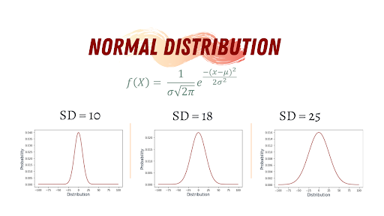

**Gaussian distribution (Normal Distribution)** is famous for its bell-like shape, and it’s one of the most commonly used distributions in data science. Many real-life phenomena follow normal distribution, such as peoples’ height, the size of things produced by machines, errors in measurements, blood pressure and grades on a test.

**Normal Distribution Characteristics**

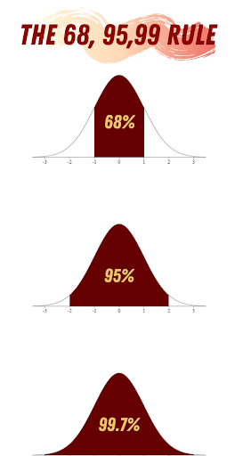

The key characteristics of the **Gaussian distribution (Normal Distribution)** are:

* The curve is symmetric at the center, which means it can be divided into two even sections around the mean.
* Because the normal distribution is a probability distribution, the area under the distribution curve is equal to one.